Memory tree activity

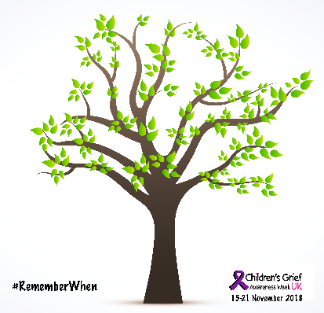
The theme for Children’s Grief Awareness Week 2018 is #RememberWhen. This sheet has a simple activity to create a display of children and young people’s memories of their person who died.
- Download the tree and print it off on white or coloured paper.
- Download the leaves and print copies off on white or coloured paper.
- Support children and young people to write memories of the person who died on their leaves, and stick them on the tree. You could give them some prompt questions eg
- everyday memories: eg What did they like for breakfast? What was their favourite song?
- special times: eg a birthday, a wedding, some special time together, favourite places.
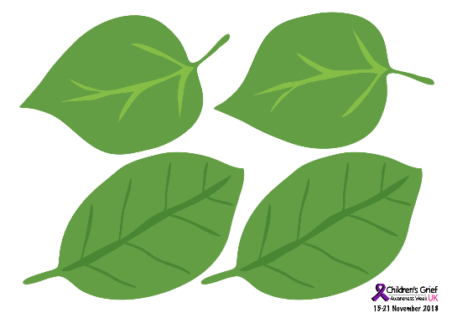
- If children don’t have memories themselves, perhaps because they were very young when the person died, you can encourage them to think about who to ask if they want to find our more. They could write their question onto a leaf and use that to open conversation with a family member or friend.
- If children have painful or difficult memories of the person who died, you could encourage them to think about a time when someone helped them in tough times – accessing memories of being supported by a family member or friend.
- Remind children of where they can get extra support.
- Take a photo of your tree display.
- Post it on social media using the hashtags #RememberWhen and #ChildrensGriefAwareness
- Visit http://www.childrensgriefawarenessweek.com/ and http://www.childhoodbereavementnetwork.org.uk/campaigns/childrens-grief-awareness-week.aspx for more information.

